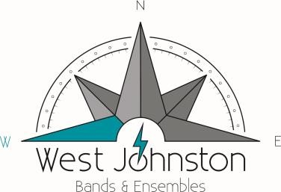
Band Parent Association
65 Glen Road, PMB 225, Garner, NC 27529
2021 - 2022  PNC UNIFORM ORDER FORM | NAME: ________________________________  PHONE: _______________________________  STUDENT: _____________________________  SECTION: _____________________________

ITEM |  | Cost | Size(s) | Quantity | Amount  Due
KNIT SHIRT* | S-XL | $22
KNIT SHIRT* | 2XL | $24
KNIT SHIRT* | 3XL | $26
KNIT SHIRT* | 4XL | $29
HAT |  | $14 | N/A
APRON |  | $20 | N/A
TOTAL
*Knit Shirt is Teal, Collared

Ways to Order:
- Print this form; place completed form WITH payment in “BLACK BOX” in BAND ROOM.
  - Note: You may have the funds taken out of your PNC earnings, if applicable, by checking “IE”, below.

- Email completed form to westbandapparel@gmail.com (as well as a screenshot of transaction) and make payment via Zelle https://www.zellepay.com/ or PayPal https://www.paypal.com/paypalme/wjhsband
(In the “Message” box/“Add a Note” box, please indicate “PNC APPAREL ORDER”).

Questions?: Contact westbandapparel@gmail.com

TOTAL AMOUNT AND PAYMENT METHOD
Cash______ Check # _________ Zelle____ PayPal _____ IE ______ Date Received:____________

